2019 Fall Baseball Interlock Rules

Pony Baseball Rules and guidelines will apply with the exception of the interlock rules listed here.

Divisions of Play (Age Groups)
- 6 and Under (6U) – The 6U division will be for ages 5 and 6. All teams must be drafted per Team Formation Guidelines below.
- 8 and Under (8U) – The 8U division will be for ages 7 and 8. All teams must be drafted per Team Formation Guidelines below.
- 10 and Under (10U) – The 10U division will be for ages 9 and 10. All teams must be drafted per Team Formation Guidelines below.
- 12 and Under (12U) – The 12U division will be for ages 11 and 12. All teams must be drafted per Team Formation Guidelines below.
- 14 and Under (14U) – The 14U division will be for ages 13 and 14. All teams will be drafted per Team Formation Guidelines below.

Any player can “play up” meaning a player may play in next older division, However – no player may “play down” in division lower than age division they should be participating in. The age determination date is August 31st of the current year. EXAMPLE: If a player is 9 years old on August 31st of the current year, they would play in the 10U division.

Game Day and Playing Rules
- Home team provides a competent scorekeeper (book) and visiting team provides a competent scoreboard operator.
- Each Head Coach must provide a roster to the scorekeeper before the game starts.
- GAME BALL – Game Balls will be provided for all home games. T-Ball must use Level 5 Safety balls.

- GAME LENGTH – 6U game time will be 1:15 with no inning starting after 1:05 finish the inning
8U game time will be 1:15 with no inning starting after 1:05 finish the inning
10U game time will be 1:30 with no inning starting after 1:20 finish the inning
12U game time will be 1:45 with no inning starting after 1:35 finish the inning
14U game time will be 1:45 with no inning starting after 1:35 finish the inning

When the game becomes mathematically impossible for a team to tie or win the score will be frozen and the scoreboard will be turned off and the game will continue as a scrimmage until the time limit is over. Those scores are as follows:
6U & 8U 11 runs ahead after the 4th inning
6 runs ahead after the 5th inning
10U & 12U 15 runs ahead after the 4th inning
8 runs ahead after the 5th inning
14U 22 runs ahead after the 4th inning
15 runs ahead after the 5th inning
8 runs ahead after the 6th inning

- RUN RULE – 6U & 8U will be 5 runs per inning (Benbrook 6U is 4 runs per inning)
10U, 12U, and 14U will be 6 runs per inning

- EXTRA INNINGS – There will be no extra innings played during the regular season

- EQUIPMENT
  - 2-⅝” barrel bats are legal in all division of PONY Baseball. If a 2-⅝” bat is -3, it must be BBCOR certified (stamped on the bats. Effective January 1, 2018, all other minus factor bats (-5, -7,-9,​ ​etc.)​ ​Must​ ​be​ ​certified​ ​with​ ​USABat​ ​licensing​ ​mark​ ​stamped​ ​on​ ​the​ ​bat.
  - T-Ball bats may be used in 4U and 6U. Baseball bats with the USA stamp may also be used in 6U during season play. During Tournaments or All-Stars T-ball bats must be used in 6U.
  - Metal cleats may be worn EXCEPT on pitching mounds
  - No jewelry may be worn during games.

- PITCHING
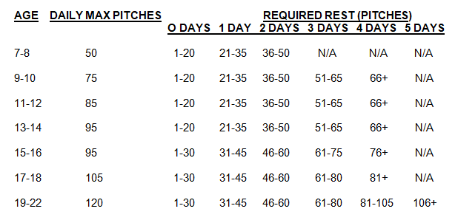
  - Pitch Count is based on the Players actual age not the age Division they are playing.
  - Pitchers reaching their maximum number of pitches in a day, while pitching to a batter, may finish pitching to that batter before being removed.
  - Rest is calculated as per calendar day.
  - No pitcher shall appear in a game as a pitcher for three consecutive days, regardless of pitch count.
  - For 10U, 12U, and 14U a team may choose to put a batter on base with no pitches thrown.

- STEALING BASES
  - 6U and 8U runners may not steal any base
  - 10U Players may not leave third base until the ball has passed home plate. Players are allowed to lead off and steal on 1st and 2nd.
  - 12U and 14U runners may steal bases as per MLB rules

- BATTING
  - 6U will get 6 swings off the tee. Games played at Benbrook or as agreed at the plate may play modified tball with 4 coach pitches and 2 off the tee.
  - 8U coach will pitch 6 pitches to the batter. If the batter swings and misses 3 times or fails to hit any of the 6 pitches he will be out due to a strike out.
  - 6U and 8U there will be no bunting allowed
  - 8U a batter may hit foul balls on the third strike until either player reaches base or a strikeout occurs
  - 10U , 12U, and 14U runners will be allowed to run on drop third strike
  - 10U, 12U and 14U No slashing allowed, will be automatic out

- 6U two defensive coach will be allowed to stand in the outfield to coach the team on the field
- 6U all defensive players must make an attempt to throw the ball. Pitcher may tag runner within 4ft of restraining line if fielded inside area (at umpires discretion) Time is called when infield has control of the ball.
- 6U and 8U will have 4 outfield players
- 6U runners may advance “ONE” base on an over throw, this includes home plate

